Muhammad Izham Bin Norhamadi  
B032020039  
S2G1  
BITZ

**Lab 1**

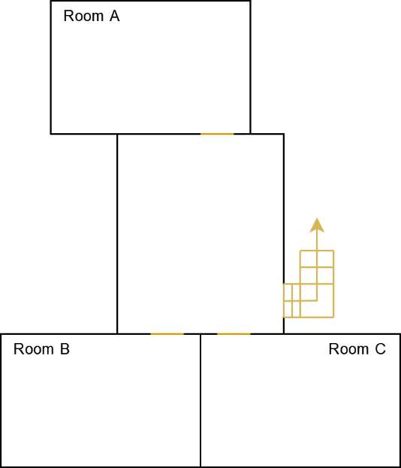

Floor map

Wi-Fi Signal Strength Map

Access-point listing

**Wi-Fi signal strength mapping process**

1. Open the Ekahau software and import the sketched floor map in png format
2. Set the scale of the map to meter
3. Navigate to the Survey tab to start surveying surrounding access points
4. Mark the starting location and start walking around the floor while mapping the movement
5. Press Enter to stop the mapping process and the software will display the findings

**Findings**

Concentrated signal in Room B is the result of TP-link access point located in the room

**AP list**

1. RumahSewa96 2.4GHz
2. RumahSewa69_Ext 5Ghz
3. [Scientex-2.4GHz@unifi](mailto:Scientex-2.4GHz@unifi) 2.4GHz
4. [Jai_Legacy_2.4GHz@unifi](mailto:Jai_Legacy_2.4GHz@unifi) 2.4GHz

**References**

* Luxul, 2011, Luxul - Using Ekahau HeatMapper™, <https://youtu.be/67TcxZs7rMo>
* Viatto, 2020, How to Perform a Passive Wireless Survey, <https://youtu.be/Pl4u87OP4Nw>
* Mikko Lauronen, 2017, Setting the scale of a map, <https://support.ekahau.com/hc/en-us/articles/202429334-Setting-the-scale-of-a-map>